DOCUMENT: SOLUTION ARCHITECTURE

Phase | Project Design Phase
Document | Solution Architecture
Project Name | PetPaws – Pet Foods & Accessories Store
Team ID | [TEAM-ID]
Date | 14 June 2026
Maximum Marks | 4 Marks

Solution Architecture — PetPaws
The PetPaws architecture follows a classic three-tier MERN (MongoDB, Express.js, React.js, Node.js) pattern with clear separation between the Presentation Layer, the API/Business Logic Layer, and the Data Access Layer. The architecture is designed for horizontal scalability, stateless authentication, and independent deployment of each tier.

Architecture Diagram (Text Representation)
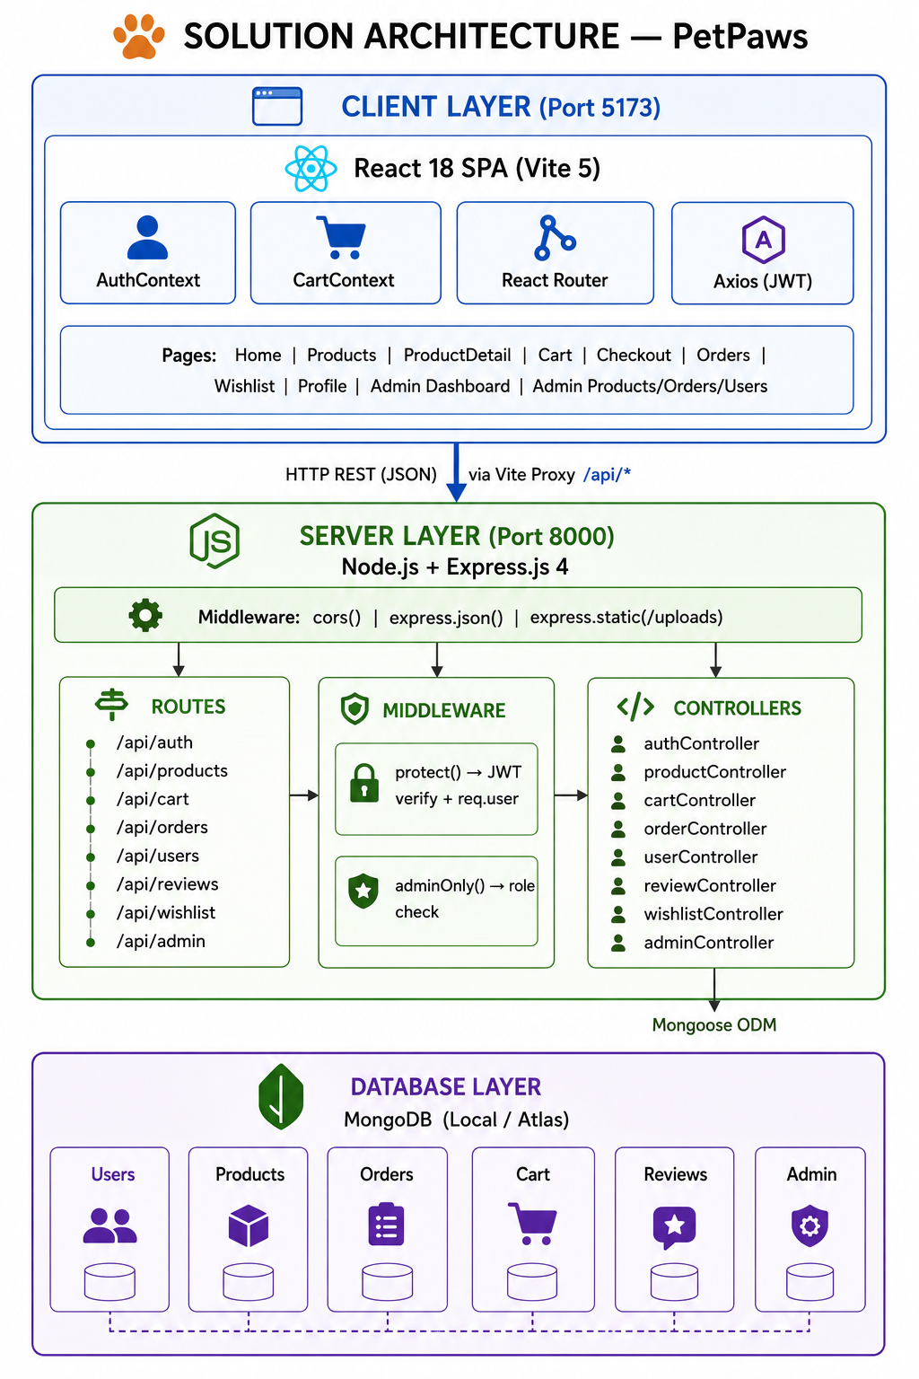

Architecture Layers
Layer | Components & Technologies
Presentation Layer | React 18 SPA (Vite 5) | AuthContext | CartContext | React Router v6 | Axios | react-hot-toast | react-icons
API / Business Logic Layer | Node.js (v18+) | Express.js 4 | JWT Middleware (protect, adminOnly) | 8 Controller modules | CORS | express.json | express.static
Data Access Layer | Mongoose ODM v8 | MongoDB (local / Atlas) | 6 Mongoose models | Text index | Aggregation pipeline
Security Layer | bcryptjs (salt:10) | JWT (jsonwebtoken) | Role-Based Access Control | Password select:false | Soft-delete | CORS whitelist
Deployment Target | Frontend: Vercel | Backend: Railway / Render | Database: MongoDB Atlas | Dev proxy: Vite /api/* → localhost:8000

Mermaid Architecture Diagram Code
